**SUPERSET ID: 6408269**

**TOPIC : MICROSERVICES WITH SPRING BOOT 3 AND SPRING CLOUD**

**EXERCISE : CREATING MICROSERVICES FOR ACCOUNT AND LOAN**

**My folder structure:**

D:\E6408269\microservices

(part 1)--🡪

ACCOUNT PROJECT :

in (src/main/java > com.cognizant.account)

**AccountController class->**

package com.cognizant.account;

import org.springframework.web.bind.annotation.*;

@RestController

@RequestMapping("/accounts")

public class AccountController {

@GetMapping("/{number}")

public Account getAccount(@PathVariable String number) {

return new Account(number, "savings", 234343);

}

static class Account {

private String number;

private String type;

private double balance;

public Account(String number, String type, double balance) {

this.number = number;

this.type = type;

this.balance = balance;

}

public String getNumber() { return number; }

public String getType() { return type; }

public double getBalance() { return balance; }

}

}

**SCREENSHOTS :**

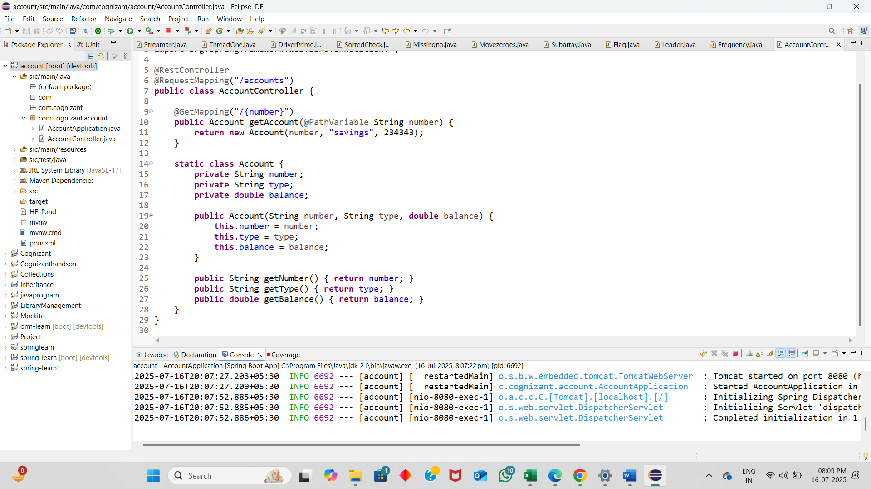

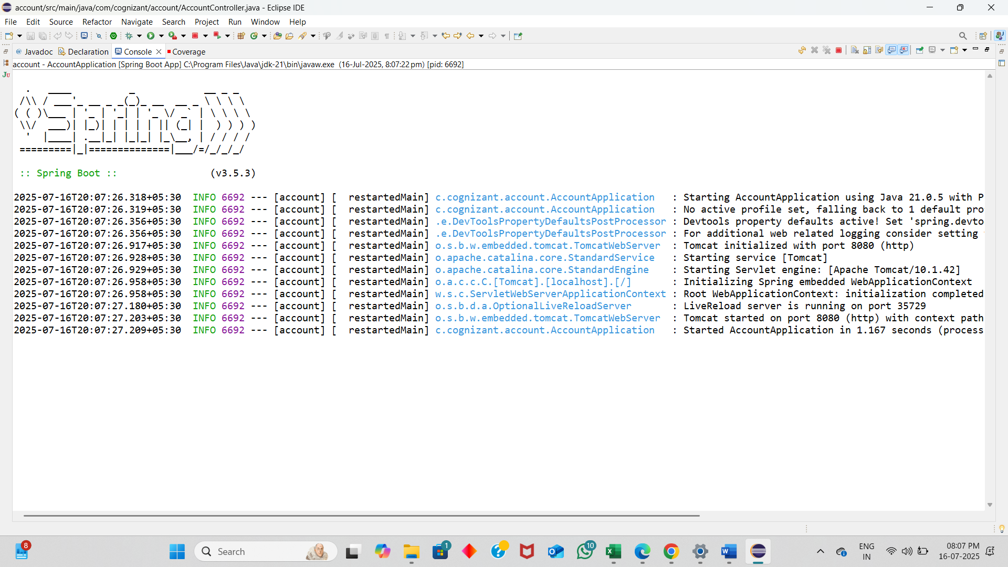

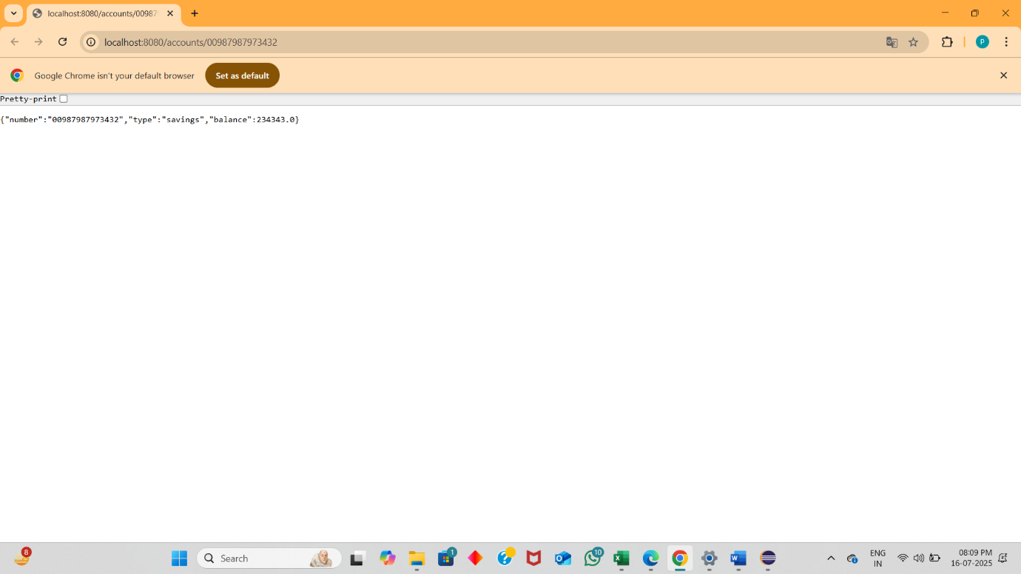

(part 2)--🡪

LOAN PROJECT :

**application properties->**

spring.application.name=loan

server.port=8081

in (src/main/java > com.cognizant.loan)

**LoanController class->**

package com.cognizant.loan;

import org.springframework.web.bind.annotation.*;

@RestController

@RequestMapping("/loans")

public class LoanController {

@GetMapping("/{number}")

public Loan getLoan(@PathVariable String number) {

return new Loan(number, "car", 400000, 3258, 18);

}

static class Loan {

private String number;

private String type;

private double loan;

private double emi;

private int tenure;

public Loan(String number, String type, double loan, double emi, int tenure) {

this.number = number;

this.type = type;

this.loan = loan;

this.emi = emi;

this.tenure = tenure;

}

public String getNumber() { return number; }

public String getType() { return type; }

public double getLoan() { return loan; }

public double getEmi() { return emi; }

public int getTenure() { return tenure; }

}

}

**SCREENSHOTS :**

